**Experiment 1**

Name: Kaushal Banthia

Roll Number: 19CS10039

Course Name: Introduction to Electronic Laboratory Course Number: (EC29003)

**Aim:**

1. Measurement of resistance and classification of capacitors.
2. Experiments under Virtual Labs

**Procedure:**

1. Identification of Resistance:

COLOUR CODING TABLE

|  |  |  |  |  |  |
| --- | --- | --- | --- | --- | --- |
| Colour | 1st Band | 2nd Band | 3rd Band | Multiplier | Tolerance |
| Black | 0 | 0 | 0 | X 1Ω |  |
| Brown | 1 | 1 | 1 | X 10Ω | +/- 1% |
| Red | 2 | 2 | 2 | X 100Ω | +/- 2% |
| Orange | 3 | 3 | 3 | X 1KΩ |  |
| Yellow | 4 | 4 | 4 | X 10KΩ |  |
| Green | 5 | 5 | 5 | X 100KΩ | +/- 0.5% |
| Blue | 6 | 6 | 6 | X 1MΩ | +/- 0.25% |
| Violet | 7 | 7 | 7 | X 10MΩ | +/- 0.1% |
| Grey | 8 | 8 | 8 |  | +/- 0.05% |
| White | 9 | 9 | 9 |  |  |
| Gold |  |  |  |  | +/- 5% |
| Silver |  |  |  |  | +/- 10% |

NOTE: If the last band is absent, then the tolerance is taken as +/- 20%

Example: For the resistor shown below,

1st Band: Yellow -> 4

2nd Band: White -> 9

3rd Band: Blue -> 6

4th Band: Black -> X 1Ω

5th Band: Red -> +/- 2%

Thus, Resistance = 496Ω +/- 2%

1. Identification of Capacitor:

The number on the capacitor represents its value.

The first two numbers represent the magnitude of a capacitor in Pico-Farads. In contrast, the third number is the multiplier, just like in a resistor, while the letter represents the tolerance of the capacitor.

Multiplier for Capacitor

|  |  |
| --- | --- |
| Third Digit | Multiplier (this times the first two digits gives you the value in Pico-Farads) |
| 0 | 1 |
| 1 | 10 |
| 2 | 100 |
| 3 | 1,000 |
| 4 | 10,000 |
| 5 | 1,00,000 |
| 6 (not used) | - |
| 7 (not used) | - |
| 8 | 0.01 |
| 9 | 0.1 |

Tolerance for Capacitor

|  |  |
| --- | --- |
| Letter Symbol | Tolerance of Capacitor |
| D | +/- 0.5pF |
| F | +/- 1% |
| G | +/- 2% |
| H | +/- 3% |
| J | +/- 5% |
| K | +/- 10% |
| M | +/- 20% |
| P | + 100%, - 0% |
| Z | + 80%, -20% |

Example: For a capacitor, if it has 321G on it, then its capacitance is 32 * 10 pF +/- 2% = 320 pF +/- 2%

Measurement:

* Ohm’s Law: It states that the current flowing across a conductor is directly proportional to the voltage applied across that conductor, with the proportionality constant being the resistance along the conductor.

$V=IR$ ($V$ is the voltage, $I$ is the current and $R$ is the resistance.

* Thevenin’s Theorem: It states that, for any linear circuit, which contains several voltages and resistances (or impedances), an equivalent circuit can be made with just one voltage source in series with one resistance (or impedance), connected across the load.

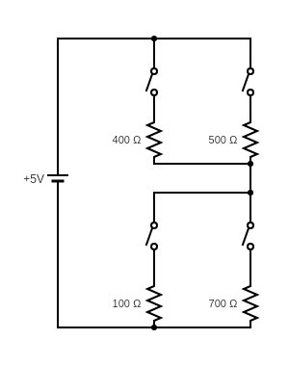

For this open circuit, let $R_{L}=700 Ω$.

Now we close all the switches and try to find the current flowing through the load.

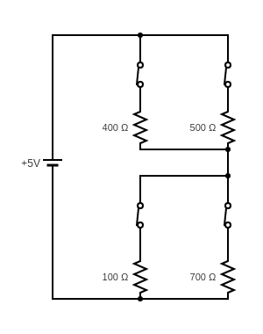

For this closed circuit, the current through the load, as given by <http://falstad.com/circuit/> is $2.018 mA$.

This value can be arrived at by using Ohm’s Law too:

The voltage of the source is $V=5 V$

Total Resistance of the circuit is $R=\frac{400*500}{900}+\frac{700*100}{800}=309.72 Ω$

Thus, the current through the whole circuit is $I=\frac{5}{309.72}=0.016 A=16 mA$

Since the voltage across the load is $V_{L}=5-0.016*\frac{500*400}{900}=1.41 V$, the load current is $I=\frac{1.41}{700}=0.002018 A= 2.018mA$

This same value can be calculated using Thevenin’s Theorem, as follows.

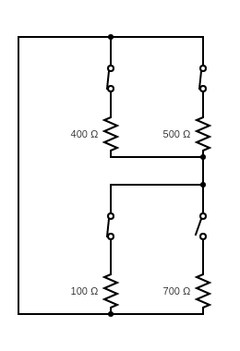

**Finding $R_{Th}$: $R_{Th}=\frac{\frac{400*500}{900}*100}{\frac{400*500}{900}+100}=68.97 Ω$**

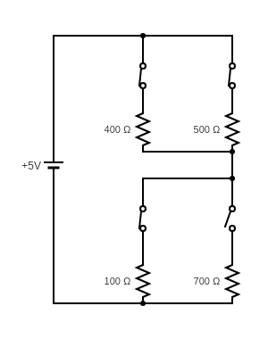

**Finding $V_{Th}$:**

$$I=\frac{5}{\frac{400*500}{900}+100}=0.016 A$$

$$V_{Th}=0.016*100=1.6 V$$

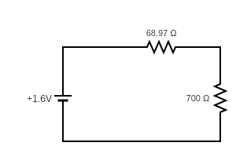

This is the equivalent circuit according to Thevenin’s Theorem.

Thus, load current $I_{L}=\frac{1.6}{700+68.97}=2.018 mA$

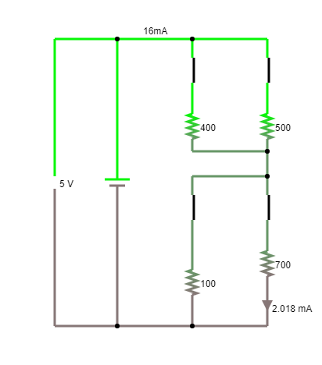

The initial circuit made in Falstad, with $R_{L}=700Ω$.

Here we can see by the ammeter that $I_{L}=2.018 mA$ and

$V_{cell}=5 V$.

**Virtual Lab Experiment:**

Theory:

* Charging:

When an uncharged capacitor is attached to a battery, it begins charging. If it were an ideal capacitor, it would have gotten charged instantly. But when the capacitors are not ideal, then the process takes infinite time to get the capacitor fully charged.

The formula for charging the capacitor, when Kirchhoff’s Voltage Law is applied across the circuit, comes out to be as follows:

$v_{c} =V(1-e^{-t/(RC)})$, where,

$v_{c}$ is the voltage across the capacitor,

$V$ is the input DC Voltage,

$R$ is the resistance of the non-ideal capacitor,

$C$ is the capacitance of the non-ideal capacitor.

The graph below depicts the formula for $V=1, R=1, C=1$

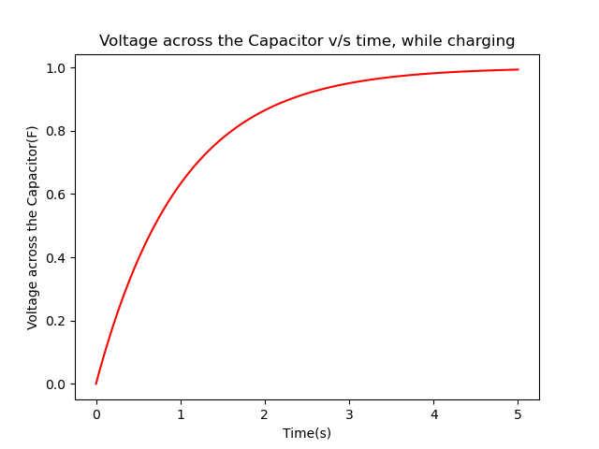

Graph Made Using the Matplotlib library in Python

* Discharging:

When a charged capacitor is attached to a resistor, it discharges. By Kirchhoff’s Voltage Law, we get the formula as:

$v_{c} = Ve^{-t/(RC)}$, where the variables denote the same parameters as in charging above.

The graph below depicts the formula for $V=1, R=1, C=1$

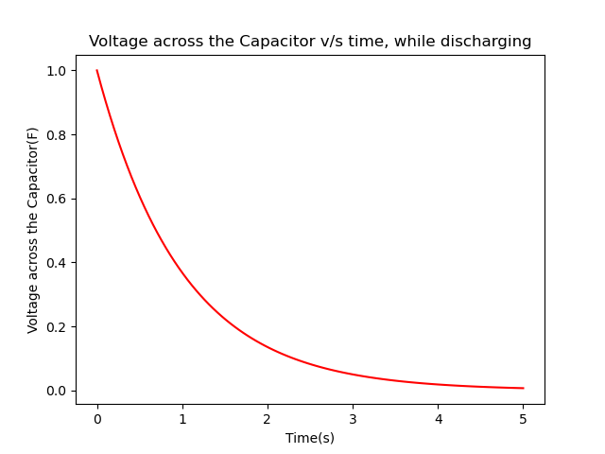

Graph Made Using the Matplotlib library in Python

**Questions**

* Consider a circuit set up like the one at the side. What will happen when the switch is closed?

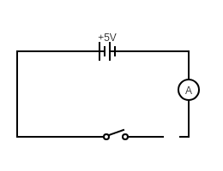

->The Ammeter will show a reading of ‘0’

* Now let’s place a large metal plate at each of the connectors a few millimetres apart. What will happen when the switch is closed?

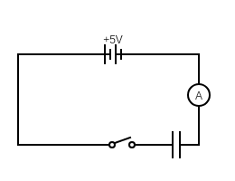

->The Ammeter will flick on one side and come back to zero.

* Let us extend this by placing a galvanometer on both sides of the capacitor and using a two-way switch. What will happen when the switch is connected to the left?

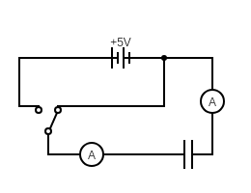

->Both of the Ammeters flick briefly to the right.

* After moving left, the switch is now moved right. What will happen?

->Both the Ammeters flick briefly to the left.

* Instead of moving to the left, the first time, if the switch is moved to the right, what will happen?

->Neither Ammeter moves.

* The behaviour of the ammeter needles in the previous experiment suggests that a current flows firstly one way, then the other as the switch is moved from left to right. So, this suggests

->Equal amounts of charge flow off one plate and onto the other.

**Conclusion:** After performing this experiment, now we can identify a resistor and capacitor, know how to measure them, using Ohm’s Law and Thevenin’s Theorem.